R. Reports Menu: C. Employee Deduction Report

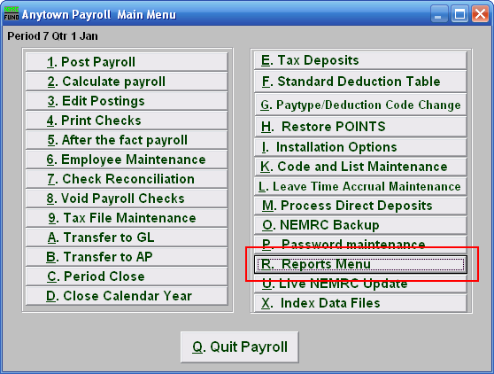
Click on “R. Reports Menu” off the Main Menu and the following window will appear:

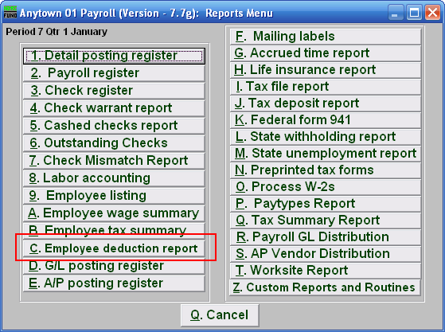
Click on “C. Employee deduction report” on the Reports Menu and the following window will appear:
Employee Deduction Report

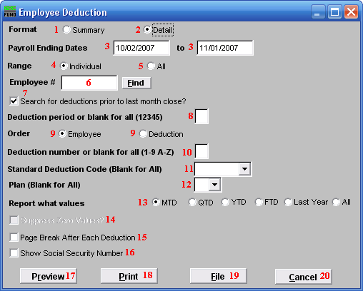
- Format: Summary: This format displays information found in “6. Employee Maintenance” off the “Deduction” tab.

- Format: Detail: This format displays information from the actual posting file including pay period ending and deduction descriptions.

- Payroll Ending Dates: Enter the beginning and ending date range of payroll ending dates to collect the data to report.

- Range: Individual: This option is only available if you chose the “Detail” format. Click on this option to have this report be for an Individual Employee.

- Range: All: This option is only available if you chose the “Detail” format. Click on this option to have this report be for All Employees.

- Employee #: This option is only available if you chose “Detail” format and “Individual” range. Select the Employee number for the employee you want this report to be for.

- Search for deductions…: This option is only available if you chose the “Detail” format. Paid postings moved to history during month close. This option allows reporting from history.

- Deduction period or blank for all (12345): The report can be restricted to a single deduction period. This option is commonly left empty for all data to appear.

- Order: Click on the order that you want this report to be in: “Employee” to list the deductions grouped by employee number; “Deduction” to list by deduction description.

- Deduction number or blank for all (1-9 A-Z): The report can be restricted to a single deduction sequence number when uniform deduction sequence numbers have been set up.

- Standard Deduction Code (Blank for All): The report can be restricted to a single standard deduction code when they have been set up and assigned to employees.

- Plan (Blank for All): The report can be restricted to deductions with a specific plan letter as defined by the IRS.

- Report what values: This option is only available if you choose the “Summary” format. Value options are month to date, quarter to date, year to date, fiscal to date, last year to date or all values.

- Suppress Zero Values?: This option is only available if you choose the “Summary” format, and do not choose “All” for the “Report what values” option. Employees with a zero value for the deduction and value options selected above with not print.

- Page Break After Each Deduction: This option is typically used when printing in deduction order for a range of dates to balance invoicing to the withholdings.

- Show Social Security Number: Reports to vendors on withholdings sometimes require the social security numbers when submitting payments.

- Preview: Click this button to preview this report. Refer to GENERAL PREVIEW for more information.

- Print: Click this button to print this report. Refer to GENERAL PRINTING for more information.

- File: Click this button to save this report on this computer. Refer to GENERAL FILE for more information.

- Cancel: Click “Cancel” to cancel and return to the previous menu.

